Tail dependence: NZDUSD and USDCAD
Method 19 / daily log returns / alpha=0.05 / Alpari D1 full available history

Study setup
Logical pair: NZDUSD , USDCAD
Broker symbols: NZDUSD_i , USDCAD_i
Snapshot: 2026-11-03_majors_alpari_D1
Timeframe: D1
Matched return window: 1999-01-05 to 2026-11-02 (UTC bar dates)
Matched return count n: 7190
Dropped unfinished last bar dated 2026-11-03 UTC after a tick-volume check against the prior complete day.
Uniforms: ranks/(n+1); alpha=0.05
Complete matched rows (Excel): NZDUSD-USDCAD_Tail_D1.xlsx
Complete matched rows (HTML table): NZDUSD-USDCAD_Tail_D1_data.html

Method carried forward
Tail dependence counts how often both legs sit in an extreme uniform tail together. Matched daily log returns of close, ln(close_t / close_t-1), become u_i = rank(x_i)/(n+1) and v_i = rank(y_i)/(n+1). At alpha=0.05, lower L_hat = (# u<=alpha and v<=alpha) / (# conditioning leg <= alpha); upper uses >= 1-alpha. Both conditioning directions are reported with numerator and denominator counts. Quotes are not inverted. L_hat(0.05) is a finite-sample frequency, not the asymptotic lambda. Same-sample Pearson r is a side check. This is not causation and not a trading signal.

Results
tail | cond | L_hat | num | denom
lower | USDCAD | 0.008357 | 3 | 359
lower | NZDUSD | 0.008357 | 3 | 359
upper | USDCAD | 0.005571 | 2 | 359
upper | NZDUSD | 0.005571 | 2 | 359
Pearson r on returns: -0.587831

Conclusion
Over 7190 matched daily rows for NZDUSD and USDCAD at alpha=0.05, lower L_hat conditioning on USDCAD is 0.0084 (3/359); conditioning on NZDUSD is 0.0084. Upper L_hat conditioning on USDCAD is 0.0056; on NZDUSD is 0.0056. Pearson r = -0.5878. These are finite-sample frequencies, not asymptotic lambda and not a trading signal.

Charts
Daily closes

Daily log returns

Uniforms with alpha lines
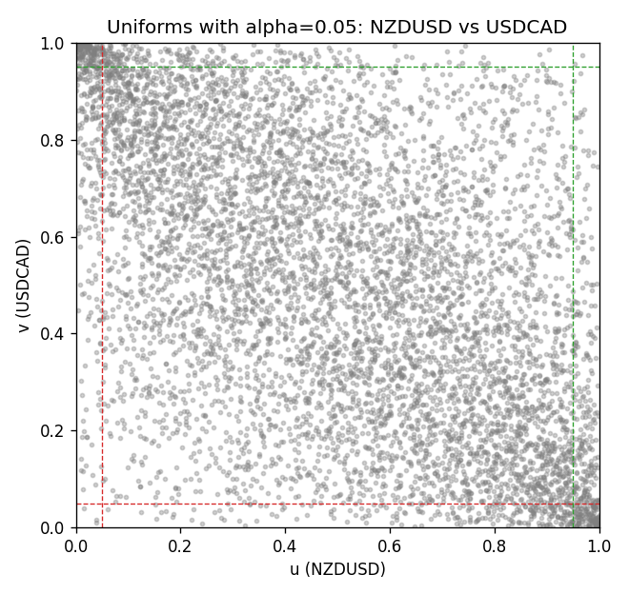

Data report
Every matched row is stored in the sibling Excel workbook named NZDUSD-USDCAD_Tail_D1.xlsx, including u and v. Embedding all rows as a Word table is impractical; this file holds column summaries and the first and last 15 matched rows.
Columns: time, NZDUSD_open, USDCAD_open, NZDUSD_high, USDCAD_high, NZDUSD_low, USDCAD_low, NZDUSD_close, USDCAD_close, NZDUSD_tick_volume, USDCAD_tick_volume, NZDUSD_spread, USDCAD_spread, NZDUSD_real_volume, USDCAD_real_volume, NZDUSD_log_return, USDCAD_log_return, u, v
Column summaries (matched calculation rows)
column | count | mean | std | min | 25% | 50% | 75% | max
NZDUSD_open | 7190 | 0.6563919 | 0.10821436 | 0.3913 | 0.5912925 | 0.6684 | 0.7249075 | 0.88218
USDCAD_open | 7190 | 1.2668559 | 0.16897553 | 0.9168 | 1.118445 | 1.298545 | 1.37213 | 1.6183
NZDUSD_high | 7190 | 0.66030697 | 0.10871111 | 0.3961 | 0.5947025 | 0.67202 | 0.72936 | 0.88421
USDCAD_high | 7190 | 1.2717549 | 0.16892987 | 0.9336 | 1.122975 | 1.30394 | 1.37655 | 1.619
NZDUSD_low | 7190 | 0.65270307 | 0.10781082 | 0.3897 | 0.5880525 | 0.664185 | 0.720965 | 0.87988
USDCAD_low | 7190 | 1.2623003 | 0.16901312 | 0.9056 | 1.114125 | 1.293585 | 1.36785 | 1.6102
NZDUSD_close | 7190 | 0.65646372 | 0.10821182 | 0.3907 | 0.5915625 | 0.66842 | 0.725015 | 0.8822
USDCAD_close | 7190 | 1.266877 | 0.16895077 | 0.916 | 1.118165 | 1.298615 | 1.372425 | 1.6137
NZDUSD_tick_volume | 7190 | 68672.777 | 123109.57 | 16 | 5561.25 | 33864.5 | 58508 | 1127682
USDCAD_tick_volume | 7190 | 80995.8 | 147287.89 | 37 | 5534 | 40938 | 71622.5 | 1410818
NZDUSD_spread | 7190 | 30.299444 | 25.655426 | 0 | 9 | 17 | 50 | 80
USDCAD_spread | 7190 | 23.448679 | 18.267866 | 0 | 9 | 17 | 40 | 60
NZDUSD_real_volume | 7190 | 1.6692087e+10 | 8.4955308e+10 | 0 | 0 | 0 | 0 | 2.705649e+12
USDCAD_real_volume | 7190 | 1.8371592e+10 | 9.6675129e+10 | 0 | 0 | 0 | 0 | 2.5751613e+12
NZDUSD_log_return | 7190 | 6.02e-06 | 0.00764513 | -0.07027433 | -0.00425619 | 0.00022347 | 0.00457637 | 0.05966839
USDCAD_log_return | 7190 | -9.38e-06 | 0.0051433 | -0.03859748 | -0.00283202 | 5.381e-05 | 0.00272817 | 0.03436319
u | 7190 | 0.5 | 0.28865506 | 0.00013906 | 0.25006953 | 0.5 | 0.74993047 | 0.99986094
v | 7190 | 0.5 | 0.28865506 | 0.00013906 | 0.25006953 | 0.5 | 0.74993047 | 0.99986094
First 15 matched rows (selected columns)
time | NZDUSD_log_return | USDCAD_log_return | u | v
1999-01-05 | -0.0018597736 | -0.010131666 | 0.37359199 | 0.026700042
1999-01-06 | 0.0020455609 | -0.0003306769 | 0.61479627 | 0.46405229
1999-01-07 | 0.0062963171 | 0.0015202092 | 0.82644973 | 0.65164789
1999-01-08 | -0.00055396548 | -0.0020495197 | 0.45167571 | 0.30385204
1999-01-11 | 0.010290425 | -0.0035137769 | 0.93032958 | 0.20748157
1999-01-12 | -0.0053157489 | 0.0066194721 | 0.20609095 | 0.92462801
1999-01-13 | -0.0099742238 | 0.0045420214 | 0.079404812 | 0.85537477
1999-01-14 | -0.00018564931 | 0.0069376546 | 0.47531637 | 0.93158114
1999-01-15 | -0.00074294208 | -0.0056905671 | 0.44096788 | 0.10721736
1999-01-18 | -0.0018597736 | 0.00098344542 | 0.37359199 | 0.59713531
1999-01-19 | 0.0018597736 | 0.002748513 | 0.60367126 | 0.75149492
1999-01-20 | 0.0040793678 | -0.0059646885 | 0.72583785 | 0.099012655
1999-01-21 | 0.0040627941 | -0.0042823796 | 0.72465582 | 0.16172994
1999-01-22 | -0.012051689 | 0.0025057712 | 0.052982895 | 0.7336949
1999-01-25 | -0.0035504102 | 0.00085579808 | 0.2864692 | 0.58517591
Last 15 matched rows (selected columns)
time | NZDUSD_log_return | USDCAD_log_return | u | v
2026-10-13 | 0.0047326165 | -0.0046395653 | 0.75803087 | 0.14893617
2026-10-14 | -0.0037306483 | 0.0015184751 | 0.27729106 | 0.65150883
2026-10-15 | 0.0047634855 | -0.0036101503 | 0.75956056 | 0.20164094
2026-10-16 | 0.0057501001 | -0.0034322068 | 0.80559032 | 0.21304408
2026-10-19 | 0.0018917133 | -0.0018835331 | 0.60645251 | 0.3181755
2026-10-20 | 0.0037199341 | -0.0037066008 | 0.70671673 | 0.1946878
2026-10-21 | 0.0030923331 | -0.00084691787 | 0.67556668 | 0.41385065
2026-10-22 | -0.0033035227 | -0.0026307268 | 0.29606453 | 0.26491448
2026-10-23 | 0.0030929853 | 2.85545e-05 | 0.67570574 | 0.49853984
2026-10-26 | -0.0028993932 | 5.7106554e-05 | 0.31664581 | 0.50048672
2026-10-27 | -0.00026399852 | 0.0025379458 | 0.46878042 | 0.7370324
2026-10-28 | -0.0097283914 | -0.0038379274 | 0.084411069 | 0.18509248
2026-10-29 | 0.00062190714 | -0.00011436495 | 0.52607426 | 0.48421638
2026-10-30 | 0.00019537668 | -0.0010298736 | 0.49853984 | 0.39535531
2026-11-02 | -0.0025962955 | 0.00061519094 | 0.33194271 | 0.56042275

